Introduction

*Cuon alpinus* that goes by various local names; Red dhole, Asiatic wild dog or Howling dog is one of the endangered species in the IUCN Red List and listed in Appendix II of CITES. Dholes can inhabit in wide range of habitats in South East Asia and known as habitat generalist (Kamlar, 2015). In Night Safari, Singapore, the dholes are kept in two separate group, 4.1 and 6.0 respectively. As a pack and highly social animal, the need of wide and big enclosure space is important for their welfare, along with environmental enrichments/complexity that are useful for the animals (Taylor, 2022).

This study is designed to investigate the relationship between environmental complexity and captive animals' behaviour. Wild habitats are challenging thus animals spend more time looking for resources, however in captive, the activities are limited depending on their enclosure and facilities. To test out the hypothesis, we will be focusing on 6.0 Red dholes in different enclosures and determine the differences in activity levels of the Red Dholes *(Cuon alpinus)* when provided with two varying environments:

1. A smaller space with the presence of more fixtures and fittings (Red Dhole 1)
2. A larger space that does not contain any unessential fixtures and fittings (Indian Wolf)

Based on the observation, the active level of the dholes was higher in Red Dhole 1 den, and certain essential social behaviours were observed as well. Inactivity level was higher in Indian Wolf den, with possibility of stereotypy behaviour. When there is no opportunity for the animals to express their natural behavior, it might lead to a monotonous and stressful lifestyle which eventually could affect their biological functions (Pritchett-Corning, 2019). On the occasion of where stationary and staring with no purpose observed, there is a possibility of animals experiencing stereotypic behavior (Caspar, 2016).

Methodology

Study sites are located at Night Safari, Singapore (1°24'08.0"N 103°47'16.6"E). There are two study sites selected for the study, which Red Dholes were transferred from their original enclosure (Red Dhole 1) to new enclosure (Indian Wolf). The dholes were observed in each den respectively which have different resources and layout.

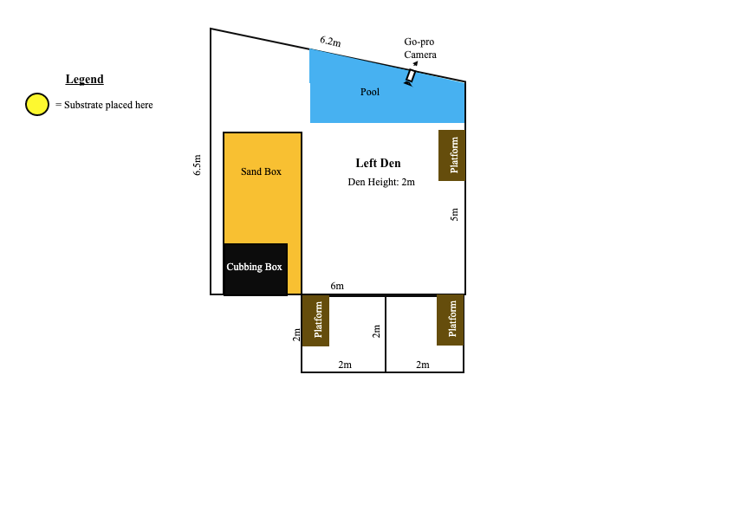

Figure 1. Red Dhole 1 den layout (need to add figure 2)

Sampling method used were scan and time sampling. An action camera was set up at each site and left to record the animals for a couple of hours during the day. The camera was set up on higher ground for Red Dhole 1 enclosure, about 2 metres height to cover wide area of the den. (Indian wolf?). Six individuals were observed for 18 days per site.

The animals were observed continuously for 10 minutes and the time frames were chosen at random where no external stimulus present for the data recording. Their behaviour is recorded at the interval of 30 seconds with 120 counts per day. Total of 2160 data points were collected for 18 days in each site. The behaviours are recorded based on the ethograms prepared.

The ethograms are divided into two states; active and inactive as shown in the Table 1 (Ghaskabdi *et. al*, 2016).

|  |  |
| --- | --- |
| **Act** | **Description** |
| **Active** | |
| C | Chewing |
| De | Defecating/Urinating |
| F | Feeding/ Drinking |
| Gr | Grooming |
| In | Interaction with Conspecifics |
| L | Licking |
| Lo | Locomotion |
| OOS | Out of Sight |
| P | Pawing/Scratching |
| Ru | Rubbing Against/Rolling Over |
| Scm | Scent Marking |
| Sm | Smelling/Sniffing |
| T | Tail wagging |
| Str | Stretching |
| Vo | Vocalisation |
| **Inactive** | |
| Sl | Sleeping/Resting Awake |
| S | Stationary |

Table 1. Ethograms for Red Dholes

The data were analysed using Excel statistic software. Stack bar graphs were plotted to see the activity and inactivity levels of the dholes between the two enclosures. R2 and R value were calculated using Excel and the formula for the correlation is as follow:

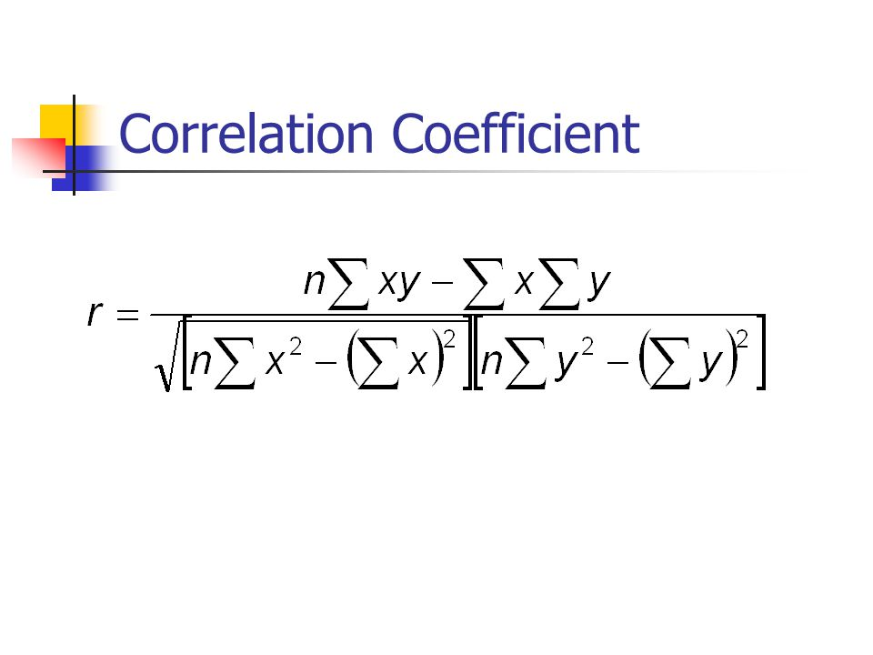

Results

Figure 3. Comparison in percentage of the dholes’ behavior in two enclosures

The dholes were seen to be more active in their original den, where more fixtures are available such as platforms, sand pit, cubbing den and pool. There is no fixture in the Indian Wolf den, apart from one water trough as can be seen in Figure 1 and 2. The active states that have high count in Red Dhole 1 enclosure comprised of inter-specific interactions, locomotive and grooming. The active behaviors for dholes in Indian Wolf are slightly different, they were seen smelling and running around for most of the observation days with few counts of defecating and grooming as shown in Appendix 1. R2 value for active level between the two enclosures is 0.2976 and R value of 0.54476.

The locomotive in Indian Wolf den was greatly reduced and animals were observed to be sleeping most of the time, with only two counts of inter-specific interactions between the dholes. Apart from that, another factor contributed for the inactivity level in Indian Wolf den is stationary, dholes were observed to be standing at one spot with no motives or interactions. The stationary behavior was not observed in Red Dhole 1 den as shown in Appendix 2. R2 value for inactivity level between the two enclosures is 0.02258 and R value is 0.15026.

Discussion

Environmental complexity is one of the major and important components for captive animals, as they face less challenges when compared to wild habitat. The complexity should be beneficial to the animals, as they can gain new skills sets and for pack animals, the skill sets will help the animal to defend their position in the hierarchy (Spinka and Wemelsfelder, 2011) which explained on the reduced con-specific interaction between the dholes in new enclosure.

The dholes were used staying in their original enclosure for a long period of time thus reducing the smelling/sniffing behavior in their daily activities and were not very much interested on the surrounding. However, this behavior was observed quite often in the new enclosure as the dholes were interested and curious about their environment. Sniffing the air provide a lot of information for the animals such as finding resources, mate and avoiding predators. When there is no opportunity for the animals to express this behavior, it might lead to a monotonous and stressful lifestyle which eventually could affect their biological functions (Pritchett-Corning, 2019).

On the occasion of where stationary and staring with no purpose observed, there is a possibility of animals experiencing stereotypic behavior. Captive animals especially social animals need the platforms, cubbing dens and sand pit to help them live in a controlled environment in order for them to express normal behaviors (Caspar, 2016). High count in locomotion would also mean they need more space to spend the energy as it was recorded that dhole have high distribution in forested areas (Widodo *et.al*, 2020), that can provide them the opportunity of finding new resources (Spinka and Wemelsfelder, 2011).

The inactivity level also comprises of sleeping and resting during the day, but Rasphone *et. al*, (2020) stated that Red dholes are highly diurnal and active at times during the night. However, in Night Safari they are displayed at night, where more enrichments and interactions happen that could possibly alter their lifestyle and habits.

Conclusion/Looking Forward

Appendices

Appendix 1: Red Dholes in original enclosure (Red Dhole 1)

|  |  |  |  |  |  |  |  |  |  |  |  |  |  |  |  |  |  |  |
| --- | --- | --- | --- | --- | --- | --- | --- | --- | --- | --- | --- | --- | --- | --- | --- | --- | --- | --- |
|  | | |  |  |  |  |  |  |  |  |  |  |  |  |  |  |  |  |
| **Day** | **C** | **De** | **F** | **Gr** | **In** | **L** | **Lo** | **OOS** | **P** | **Ru** | **S** | **Scm** | **Sl** | **Sm** | **Str** | **T** | **Vo** | **Total Data Points** |
| Day 1 |  |  |  |  | 2 |  | 3 | 26 |  |  |  |  | 87 | 2 |  |  |  | 120 |
| Day 2 |  |  |  |  | 5 |  | 11 | 35 |  |  |  |  | 69 |  |  |  |  | 120 |
| Day 3 |  |  |  |  |  |  | 5 | 17 |  |  |  |  | 98 |  |  |  |  | 120 |
| Day 4 |  | 1 |  | 1 | 2 |  | 34 | 38 |  |  |  |  | 44 |  |  |  |  | 120 |
| Day 5 |  | 2 |  |  | 1 |  | 3 | 32 |  |  |  |  | 82 |  |  |  |  | 120 |
| Day 6 |  |  |  |  |  |  |  | 22 |  |  |  |  | 98 |  |  |  |  | 120 |
| Day 7 |  |  |  |  | 1 |  | 28 | 31 |  |  |  |  | 60 |  |  |  |  | 120 |
| Day 8 |  |  |  |  |  |  | 39 | 33 |  |  |  |  | 48 |  |  |  |  | 120 |
| Day 9 |  |  |  | 4 |  |  | 8 | 14 |  |  |  |  | 94 |  |  |  |  | 120 |
| Day 10 |  |  |  |  |  |  | 12 | 38 |  |  |  |  | 68 | 2 |  |  |  | 120 |
| Day 11 |  |  |  | 1 | 4 |  | 13 | 15 |  |  |  |  | 87 |  |  |  |  | 120 |
| Day 12 |  | 1 |  |  | 4 |  | 9 | 25 |  |  |  |  | 81 |  |  |  |  | 120 |
| Day 13 |  |  |  | 1 |  |  | 34 | 29 |  |  |  |  | 56 |  |  |  |  | 120 |
| Day 14 |  |  |  |  |  |  | 66 | 35 |  |  |  |  | 18 | 1 |  |  |  | 120 |
| Day 15 |  |  |  |  |  |  | 6 | 36 |  |  |  |  | 78 |  |  |  |  | 120 |
| Day 16 |  | 2 |  |  |  |  | 49 | 32 |  |  |  |  | 37 |  |  |  |  | 120 |
| Day 17 |  |  |  | 3 | 1 |  | 19 | 17 |  | 3 |  |  | 77 |  |  |  |  | 120 |
| Day 18 |  |  |  |  | 4 |  | 2 |  |  |  |  |  | 114 |  |  |  |  | 120 |
| Totals (18) | 0 | 6 | 0 | 10 | 24 | 0 | 341 | 475 | 0 | 3 | 0 | 0 | 1296 | 5 | 0 | 0 | 0 | 2160 |

Appendix 2: Red Dholes in new enclosure (Indian Wolf)

|  |  |  |  |  |  |  |  |  |  |  |  |  |  |  |  |  |  |  |
| --- | --- | --- | --- | --- | --- | --- | --- | --- | --- | --- | --- | --- | --- | --- | --- | --- | --- | --- |
| **Date** | **C** | **De** | **F** | **Gr** | **In** | **L** | **Lo** | **OOS** | **P** | **Ru** | **S** | **Scm** | **Sl** | **Sm** | **Str** | **T** | **Vo** |  |
| Day 1 |  |  |  |  |  |  |  |  |  |  |  |  | 120 |  |  |  |  | 120 |
| Day 2 |  |  |  |  |  |  |  |  |  |  |  |  | 120 |  |  |  |  | 120 |
| Day 3 |  |  |  |  |  |  |  | 20 |  |  | 1 |  | 99 |  |  |  |  | 120 |
| Day 4 |  |  |  |  |  |  | 1 | 3 |  |  | 3 |  | 112 | 1 |  |  |  | 120 |
| Day 5 |  |  |  |  |  |  |  |  |  |  |  |  | 120 |  |  |  |  | 120 |
| Day 6 |  | 1 |  |  |  |  |  |  |  |  |  |  | 117 | 2 |  |  |  | 120 |
| Day 7 |  |  |  | 2 |  |  | 3 | 9 |  |  | 2 |  | 101 | 3 |  |  |  | 120 |
| Day 8 |  |  |  |  |  |  | 5 | 9 |  |  | 4 |  | 99 | 3 |  |  |  | 120 |
| Day 9 |  |  |  |  |  |  | 6 | 20 |  |  | 2 |  | 92 |  |  |  |  | 120 |
| Day 10 |  | 1 |  |  |  |  | 16 | 21 |  |  | 1 |  | 80 | 1 |  |  |  | 120 |
| Day 11 |  |  |  |  |  |  | 2 | 25 |  |  | 1 |  | 90 | 2 |  |  |  | 120 |
| Day 12 |  |  |  |  |  |  | 1 |  |  |  | 3 |  | 115 | 1 |  |  |  | 120 |
| Day 13 |  |  |  |  | 2 |  | 10 | 7 |  |  | 1 |  | 97 | 3 |  |  |  | 120 |
| Day 14 |  |  |  |  |  |  | 12 |  |  |  | 1 |  | 107 |  |  |  |  | 120 |
| Day 15 |  |  |  |  |  |  | 7 | 4 |  |  | 5 |  | 103 | 1 |  |  |  | 120 |
| Day 16 |  |  |  |  |  |  | 22 | 5 |  |  | 3 |  | 90 |  |  |  |  | 120 |
| Day 17 |  |  |  |  |  |  | 2 |  |  |  | 1 |  | 117 |  |  |  |  | 120 |
| Day 18 |  | 1 |  |  |  |  | 8 | 2 |  |  | 1 |  | 108 |  |  |  |  | 120 |
| Totals (18) | 0 | 3 | 0 | 2 | 2 | 0 | 95 | 125 | 0 | 0 | 29 | 0 | 1887 | 17 | 0 | 0 | 0 | 2160 |

References

Caspar, G. (2016). Fact Sheet: Environmental Enrichment. Greyhound Racing NSW. Pp 1-5

Ghaskabdi, P., Habib, B. & Qureshi, Q. (2016). A whistle in the woods: an ethogram and activity budget for the dhole in central India. Journal of Mammalogy 97(6): 1745- 1752. DOI: 10.1093/jmammal/gyw141

Kamler, J. F., Johnson, A., Vongkhameng, C., & Bousa, A. (2012). The diet, prey selection, and activity of dholes (Cuon alpinus) in northern Laos. Journal of Mammalogy 93(3): 627-633. DOI: DOI: 10.1644/11-MAMM-A-241.1

Kamler, J.F., Songsasen, N., Jenks, K., Srivathsa, A., Sheng, L. & Kunkel, K. 2015. Cuon alpinus. The IUCN Red List of Threatened Species 2015: e.T5953A72477893. <http://dx.doi.org/10.2305/IUCN.UK.2015-4.RLTS.T5953A72477893.en>

Pritchett-Corning, K., R. (2019). Environmental Complexity and Research Outcomes. ILAR Journal 60(2): 239-251. DOI: 10.1093/ilar/ilaa007

Rasphone, A., Kamler, J. F., & Macdonald, D., W. (2020). Temporal partitioning by felids, dholes and their potential prey in northern Laos. Mammal Research 65: 679-689. DOI: <https://doi.org/10.1007/s13364-020-00524-9>

Špinka, M., & Wemelsfelder, F. (2011). Environmental challenge and animal agency. Animal welfare. Wallingford, UK: CAB International. p, 27-44.

Taylor, P.S.; Hemsworth, P.H.; Rault, J.-L. Environmental Complexity: Additional Human Visual Contact Reduced Meat Chickens’ Fear of Humans and Physical Items Altered Pecking Behavior. Animals 2022, 12, 310. DOI: https://doi.org/10.3390/ ani12030310

Widodo, F. A., Sunarto, Hartoyo, D., Gunawan, Fadhli, N., Sukmantoro, W., Zulfahmi, Septayuda, E., & Adzan, G. (2020). Preliminary assessment of abundance and distribution of Dholes Cuon alpinus in Rimbang Baling and Tesso Nilo landscapes, Sumatra. *Raffles Bulletin of Zoology* 68: 387 – 395. DOI: 10.26107/RBZ-2020-0055